Keegan Smith

Intro to Data Communications

4/3/2023

HW 6

1. 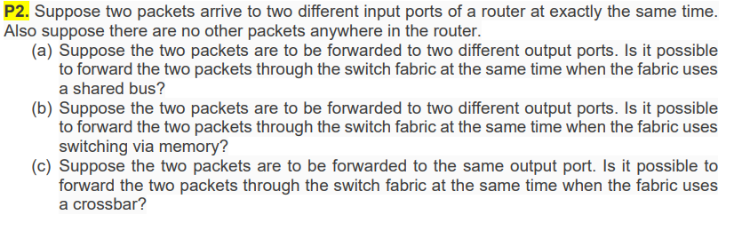It is not possible for the packets to go through the switch fabric at the same time as only one packet at time can be transmitted over a shared bus.
2. Yes, two packets can be transmitted through the switch fabric at the same time if they are going to different output ports.
3. It is not possible to forward two packets though the switch fabric at the same time when the fabric uses cross bar. This is because each input and output port in crossbar can only read or write one packets at a time.

|  |  |
| --- | --- |
| Prefix Match | Link Interface |
| 11100000 00 | 0 |
| 11100000 010000000 | 1 |
| 1110000 | 2 |
| 11100001 1 | 3 |
| Otherwise | 3 |

1. Forwarding tables match prefix o the first few bits of given destination address with the above table. If the prefix match column value is less than the prefix of the destination address, then the corresponding link interface is assigned.

|  |  |
| --- | --- |
| 11001000 10010001 01010001 01010101 (4th entry) | 3 |
| 11100001 01000000 11000011 00111100 (2nd entry) | 1 |
| 11100001 10000000 00010001 01110111 (3rd entry) | 2 |

|  |  |  |
| --- | --- | --- |
| Destination Address Range | Link Interface | Addresses in range |
| 00000000 through 00111111 | 0 | 64 |
| 01000000 through 01011111 | 1 | 32 |
| 01100000 through 01111111 | 2 | 96 |
| 10000000 through 1000000 | 3 | 64 |
| 11000000 through 1100000 | 4 |  |

|  |  |
| --- | --- |
| Subnet | Network addresses |
| 1 | 223.1.17.125/25 |
| 2 | 223.1.17.191/26 |
| 3 | 223.1.17.192/28 |

|  |  |
| --- | --- |
| 224.0.0.0/10 | 0 |
| 224.64.0.0/16 | 1 |
| 224.0.0.0/8 | 2 |
| 225.128.0.0/9 | 3 |
| Otherwise | 3 |

128.119.40.64/27, 128.119.40.92/27, 128.119.40.120/27, 128.119.40.148/27 are the IPs of the four subnets.

|  |  |  |  |
| --- | --- | --- | --- |
| Inside Local IP | Inside Global IP | Outside Local IP | Outside Global IP |
| 192.168.1.2 | 24.34.112.235 | 128.119.40.86 | 128.119.40.86 |
| 192.168.1.3 | 24.34.112.235 | 128.119.40.86 | 128.119.40.86 |
| 192.168.1.4 | 24.34.112.235 | 128.119.40.86 | 128.119.40.86 |
| 192.168.1.5 | 24.34.112.235 | 128.119.40.86 | 128.119.40.86 |
| 192.168.1.6 | 24.34.112.235 | 128.119.40.86 | 128.119.40.86 |
| 192.168.1.7 | 24.34.112.235 | 128.119.40.86 | 128.119.40.86 |